
Year 8

Mini Test

Statistics

Total Marks: 30 marks
Name: __________________________________ Total Time: 30 minutes

Show working and answers on this sheet. Show working in sufficient detail to support your answers. Incorrect answers without supporting reasoning may be allocated zero marks.

Resources Allowed: Calculator, 1-sided Notes Page

Question 1 8 marks

Use the following words (once) to complete the following sentences.
Outlier Mode Median Mean Census Sample Range Biased

- The ______________ is the most common value in a set of data.
- A score that is much larger or smaller than the rest of the data is known as an ____________ .
- When data is placed in order, the middle point is known as the _________________ .
- When a survey is conducted that is deliberately unfair, that survey is said to be ________________ .

- When finding the median for an even set of data, we calculate the ____________ of the two middle values
thereby finding the median.

f) A collection of data from the whole population is called a _______________ whereas a collection of data from part of the population is called a __________________.

g) In a set of data the ______________ is found subtracting the lowest value from highest value.

Question 2 4 marks

The following stem-and leaf plot represents scores achieved by 12 students on their latest science assignment.

Use the data to calculate the mean, median, mode and range

a) Mean

b) Mode

c) Median

d) Range

Stem │ Leaf 2│2 means 22
0 │ 7
1 │ 2 3 8
2 │ 2 5 5 7
3 │ 1 1 6
4 │ 7

Question 3 9 marks

The data below shows the number of DVDs rented from Video Buster each day over a 20-day period.
72 | 59 | 67 | 84
75 | 64 | 28 | 46
62 | 83 | 55 | 60
41 | 60 | 79 | 68
53 | 72 | 80 | 73

- Complete the following grouped frequency table. (3 Marks)

(HINT: Start by completing the class intervals 0–9, 10–19, 20–29, etc.)

Class interval | Tally | Frequency
0 - 9
10 - 19
20 - 29
30 - 39
Total

b) Use the axes below to draw a frequency histogram of the data. (4 Marks)

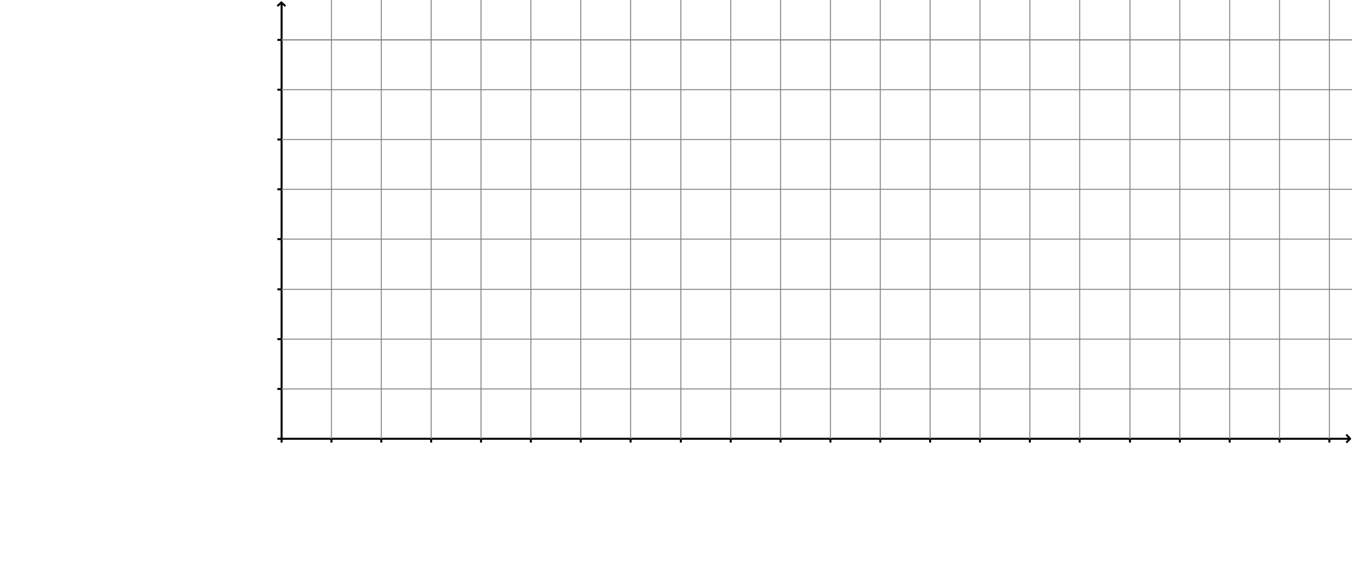

c) On how many days were at least 70 DVDs rented? (1 mark)

d) Is this type of data an example of categorical or numerical data? (1 mark)

Question 4 3 marks

Shop owner Bill, has a shop. The daily sales over a 16 day period are monitored and recorded as follows.

3 7 8 9 12 13 14 15 15 15 21 22 24 26 27 28

a) Draw an ordered stem and leaf plot

Stem Leaf

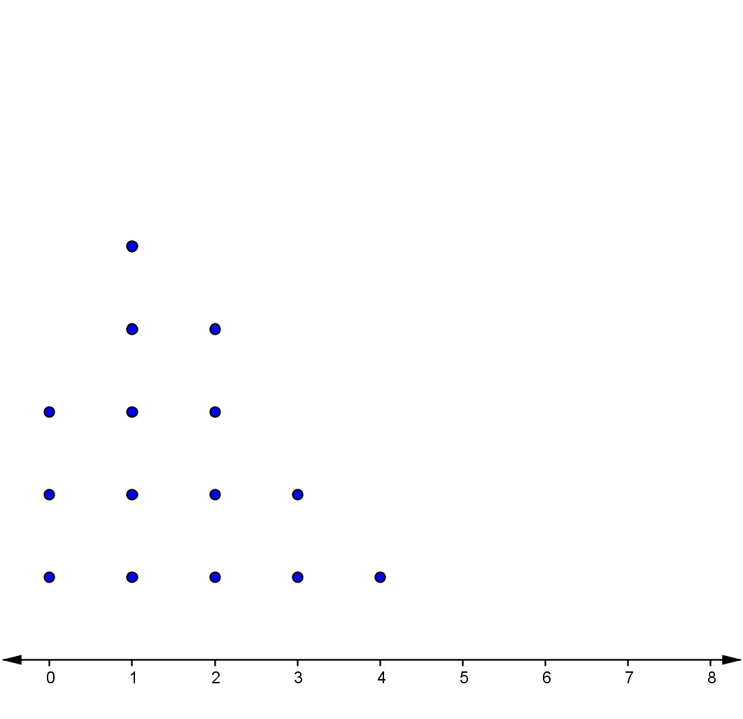
Question 6 4 marks

Refer to the following dot plot. This dot plot shows the frequency of households with 0, 1, 2, 3 or 4 pets. (Each dot represents 1 pet)
Pets in households

Multiple Choice.

a) How many households were surveyed?
A 15 B 4 C 30 D 5 E 1

b) The median number of pets is:
A 15 B 4 C 30 D 5 E 1

c) The range of the set of data displayed in the dot plot is:
A 15 B 4 C 30 D 5 E 1

d) The modal (mode) number of pets is:
A 15 B 4 C 30 D 5 E 1

Question 7- Extension 2 marks

Jackson obtained the following scores on his first five Maths tests:

92 89 94 82 93

If there is one more test left to complete, and he wants to achieve an average of at least 85, what is the lowest score Jackson can obtain for his final test?

